WGTC Board Meeting Minutes
Tuesday, November 8, 2022
6:30 pm

Open meeting 6:35 pm
- Roll Call - Jon absent (London)
Terie, Cindy, Jonathan, Katelyn, Marian, Maria present
- Approve Agenda as presented
- Approve last two Board meetings’ minutes

- Items to follow up from last meeting:
- Find way to thank high school for their work
Terie ask when class is so can send pizza Christmas
- Track Tuesday (Carrollton High School)
Terie needs specific dates. First Tues. 6:15 pm. When to start?
Can’t use h.s. Track - they’re redoing it so can revisit once complete
Marian to reach out to Tyler to see if ok to promote Sole Roots Track Tues to our club.

- Board Member/Committee Reports

A. President - Terie
- March race committee met twice.
Amber Nixon joined.
- Sponsorships
- Cindy - Scott Evans confirmed, Elite Health Care, Tommy’s Car Wash, United Comm. Bank
- Maria to make spreadsheet of sponsors.
- potentials
Eagle Adv., Morgan Oil, Superior Rec., Southern Therapy, Tsinger Vance, Jason Templeton poss. donate bags etc.
Terie to reach out to roofing company, turf company, Josh Harper ($300).
West GA cycling agreed to do bike lead.
Katelyn reach out to ITL, Printer’s.
Jonathan - Southwire
- Committee decided to give everyone a medal, and top winners water bottle. 5k winners get cup with logo. (Robinson’s donated- does not want any recognition.)
- Estimate projected profit 5700.
- Committee wants Tyler to time race. But not ask until confirm Bill is doing half.
Quotes from both. Not decide now.
Consider India or someone else as race announcer.
Next meeting of committee in Dec. and Terie will report back.
B. Secretary - Maria
- Bylaws - sent updated version to Board.
Need to approve/send to members
Correct 501c7, fix address in blue box title page, remove website manager from board and become a committee
Maria update and confirm with board before sending to members.
2. Member duties - sent updated version to Board.
Review and confirm expectations.
Everyone email notes to Katelyn by end of Nov. and will present at Dec. meeting.
C. Membership - Marian
Group runs - local businesses Thursdays, include Sole Roots in the rotation
20% road id discount from Terie to add to member email
Advertise Jonathan and Katelyn’s wedding run to members
105 members - same this time last year
Some confusing issues with automated messages with runsignup when someone signs up. Join and renewal dates for some individuals seem incorrect.
Outdated messages being sent out upon sign up. Will fix and follow up. Send to Jonathan for help.
Terie suggest 1-2 runs/month at Castle Playground to be sure to clean up greenbelt. First Sat. every month.

D. Director of Operations - Katelyn
Confirmed individual asked to be removed is not on mailchimp list
E. Merchandise - Cindy
New shirts set up to order through Nov. 30 guarantee receive by Dec. 15. Cycles every 30 days. Ozier will send invoice and we’ll give to Jon.
F. Treasurer - Maria for Jon - read report that is in drive.
Oct 1 - Nov 1 financial details below

This week’s Thurs. Group run - Jonathan
Saturday - Jon, Cindy
Group run Dec. 15 holiday attire (advertise).
First week in Dec. Katelyn will email that Circuit start again.
Move it Monday call for spring volunteer.
Next meeting Dec. 13
7:50 meeting adjourned

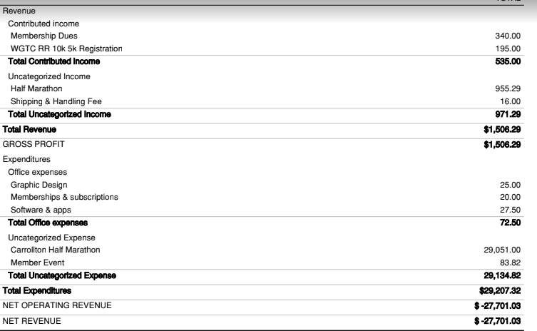

Fiscal year
