WGTC Board Meeting Agenda
Wednesday, June 14, 2023
6:00 pm via Google Meet

(note that virtual meeting is limited to 1 hour)

Meeting link
https://meet.google.com/acr-iwsx-uxr

- Roll Call - Jon, Maria, Marian, Terie, Cindy. Amber absent.

- President - Terie
- Review comparison chart from Marian for race quotes (Sole Roots and Elite)
- Motion to vote approved - Sole Roots approved
Terie to contact both tomorrow.
- Approved Agenda
- Approved last meeting’s minutes

B. Executive Administrator - Maria
- Passwords updated (notified via email and list updated in drive)
Check with Christin for Paypal.
Check with Marian about other questionable contacts.

- Members Night Members night - June 17, 6-8 pm
- 22 attending (RSVP) - 24 including speakers Tyler and Christin
- Nominations
i. Membership - Susan Holland
- Saturday plans - Who’s doing what?
i. set up
There are tables and chairs there - 8 picnic tables
Jon and Marian bring extra folding tables
Marian: Ask John Crosby about table cloth - Anthony backdrop
Cleaning stuff for tables
Serving utensils
ii. food pick up (What’s been ordered? From where?)
Marian asking Amber - La Salsa
iii. Water / Tea - Terie
iv. cooler/ice - Maria
v. door prizes - get donations, bring notepad, pens for write name to pull out of hat
vi. intro/speakers
vii. table decor - Maria
viii.napkins/dinner and dessert plates, silverware/cups, trash bags
Ask Amber - tell Cindy what to get
ix. dessert - cake order/pickup Publix - Cindy

Jon bring cash for guests or use his venmo for $10 charge

Maria - Update plan excel with order of events
Business votes after dinner, then intro speakers, then close

3. Sat. Group Run at Castle Playground - greenbelt clean up
- Who’s leading/attending?
- John Crosby - cleaning items
4. Members night 2024
- select next years’ date and schedule location in advance - decide in July meeting

C. Treasurer - Jon
- May financial report
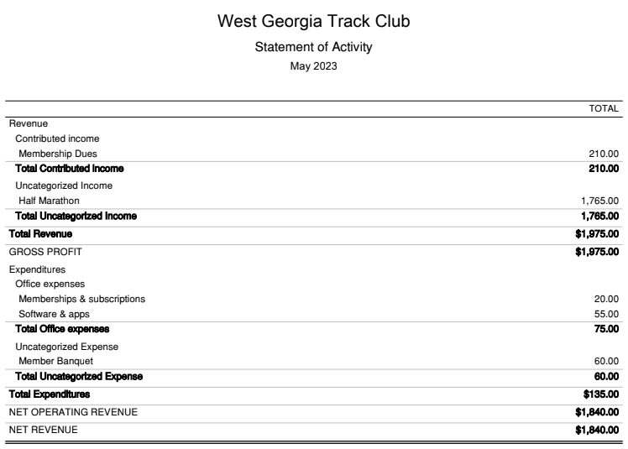
- Year to date report
- Review proposed annual budget
- Will vote on at members night
- Previous budget did not include income from half race - this is why shows as larger increase in overall budget
- Terie planning to go to RRCA convention next year

D. Vice President - Marian
- Membership spotlight - Kadwin to be sent out this week
- next: Frank, Terie, Susan?
- 1-2 times/year feature board member

2. Do some updates on website for new board members

3. run sign up notification emails - removed “director” notice
can update for who wants access
Marian update Terie, Jon as “director” so they receive notices.

Adjourn 6:53 pm

